

CHALLENGE NAME: [Follow for Clues]   
DEV : [Abhinav]

CATEGORY: [OSINT]   
LEVEL: []

2025



CHALLENGE NAME: [Follow for Clues]

**Challenge Description**:   
🔍 Stay updated:

📌 Follow us on LinkedIn, Instagram, and Twitter 💬 Join our Discord for updates

**Solution:**For this challenge just visit our social media profiles and view our recent posts form those social media sites.  
From that we can find the flag at description of one of the Instagram posts  
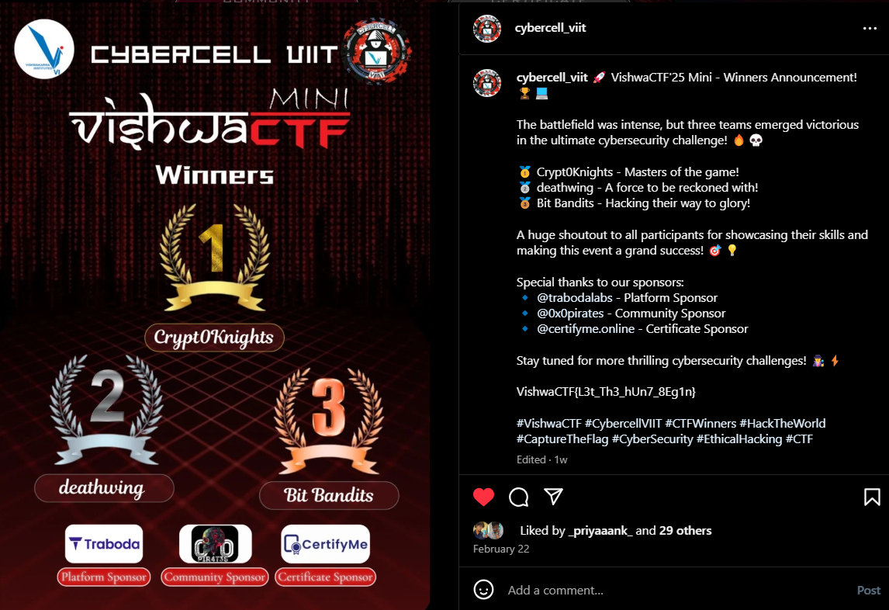

**Flag: VishwaCTF{L3t_Th3_hUn7_8Eg1n}**

DEV: [] **1**